Report on UN Commission on the Status of Women for 2012: (CSW 56)
WOMEN A PRIORITY AT THE UNITED NATIONS
All of us, men and women, must take action. Only through women’s full and equal participation, in all areas of public and private lives can we hope to achieve a sustainable, peaceful and just society. Ban Ki Moon
Pamela Tankersley
United Nations Convener
Presbyterian Women (APW)
Aotearoa New Zealand
27 February – 39March 2011

Background
APW was granted special consultative status, the first NZ national body to achieve this after the UN ECOSOC agreed in 1997 to grant status to national organizations, not just international. APW had the status granted in July 1998. The status allows us to attend any meeting convened by the ECOSOC .
The President, Mrs Jane Prichard, attended the 4th UN Conference on Women in Beijing,
Since that time there has been a UN Committee as part of the national organisation of APW and the Conveners of that committee have usually taken up the opportunity to attend the annual Commission, to join with other NZ NGO’s, advise the NZ government delegation its opinion on the issues being discussed and to participate in NGO briefings at the time.
We are one of the very few national NGOs that have such status: most of the teams that comes from NZ are part of an international team (for instance the Girl Guides).We also participated fully in the parallel events run by the various NGO’s.

CSW 56
The Commission on the Status of Women is the primary global policy-making body of the UN devoted entirely to examining the state of progress for women in member states.
Women still comprise the majority of the world’s poor, and 43% of the worlds food is produced by women. There are huge disparities in the status and power of women to mange their own lives and that of their families, and obtaining equal pay for equal work and unpaid work, there is continued high maternal mortality , prominent HIV/Aids infection, a pandemic of violence against women, high frequency of genital mutilation and appalling sex trafficking/slavery of young women. These issues determining the rights of women are human rights issues and the CSW is calling all member states to implement a commitment to progress.
On the other hand, countries with greater gender equality have more competitive and faster growing economies, the presence women in leadership in peace-making increases the possibility of harmonious outcomes and greater security and infant and maternal mortality is raised. Progress towards the Millennium Development Goals is enhanced.

This year the theme for the CSW was ”the empowerment of rural women and their role in poverty and hunger eradication, development and current challenges.” In the first of its agreed conclusion, the Commission states:
The Commission recognises rural women as leaders, decision makers, producers, workers, entrepreneurs, and service providers who contribute to local and national economies, rural development, agriculture, and household livelihoods. Their contributions, which are not often fully acknowledged, are a pre-requisite for economic growth ad development. It notes the potential of empowering rural women for poverty and hunger eradication, sustainable development, and accelerated progress towards achieving internationally agreed development goals, including the Millennium Development Goals by 2015. The Commission acknowledges the heterogeneity of rural women and the need to address discrimination and inequalities they face in the basis of a range of factors.

In the first week of formal sessions, each member state made its statement reporting the condition in its state, a set of draft recommendations were proposed and member state delegations and also NGOs were invited to suggest amendments. I worked with Ecumenical Women’s advocacy group to draft an amendment that encouraged member states to support better access to safe and reliable transportation to markets, to education and medical care, to food and water. This amendment was circulated to several member states missions and we were pleased that the NZ Mission incorporated it into their submissions for change in the agreed conclusions.
The second week was spent debating to reach an agreed document. Sadly this year, no consensus was able to be found.

NZ Government Delegation
The NZ government delegation was led by Deb Moran, Policy Director, Ministry of Women’s Affairs and included MWA policy analyst Nicole Bernkert and Julia Collins, from the Department of Agriculture and Fisheries. They were assisted by the staff of the NZ Permanent Mission to the United Nations.

We were well served by our delegation: we had attended a meeting in Wellington prior to leaving for the UN, and in New York, their enthusiastic consultation with us as NGOs and the exchange of feedback between government and NGO delegations was significant as we met for debriefing at the end of each day. We were also invited to the NZ Mission to the UN for breakfast one morning. We note that New Zealand is currently a member of the UN Women Executive Board.

The presentation made by the NZ delegation was honest and reflected rural women’s status in NZ well. This year’s theme was a “development” one and as a highly developed nation we are comparatively advanced.
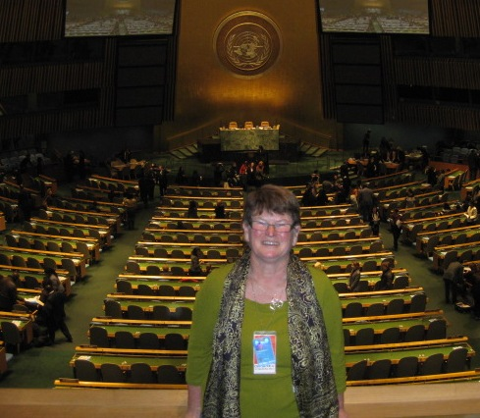
The points made were:
- Rural women in NZ are farm owners, farmers and farm managers in their own right, and contribute significantly to the success of NZ in the primary produce sector
- Women support the rural sector in its vital services and also do more unpaid work than either their urban or make rural counterparts,
- Rural women provide excellent advocacy and leadership in our society
- The settlement process for the Treaty of Waitangi has increased the asset base for Maori in the primary sector
- Access to services for rural women is an issue and ultra-fast broadband service will mitigate against this
- Rural women suffer as much violence as their urban counterparts, but geographical isolation and smaller communities of support exacerbates this.

The NZ Mission offered a panel discussion (in conjunction with Australia) at which Marilyn Waring spoke (somewhat provocatively) about the progress of women’s issues in the Pacific,

Ecumenical Women
It was a joy to connect again with Ecumenical Women, an alliance of women of faith, coming together for the CSW. We had participated on-line before we reached NY and I appreciated the orientation day, the warm welcome from those I had met before, and the opportunity to work in a bigger group to formulate a programme of advocacy, from a faith perspective.
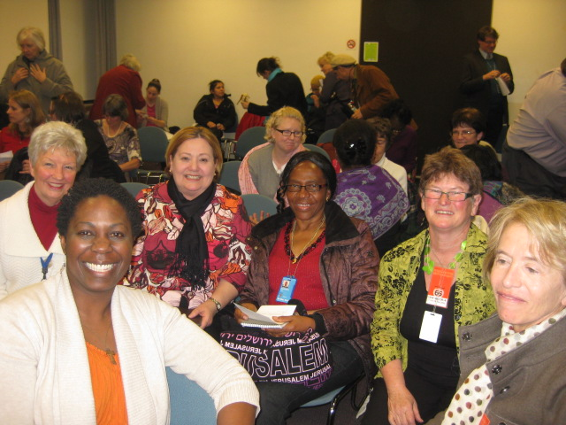
The talking points for advocacy for rural women (that we would discuss with our delegations) we agreed on together, covered:
- Climate Change, Farming and Food security
- Access to Education
- Transportation and Access to Resources
- Access to Medical Care
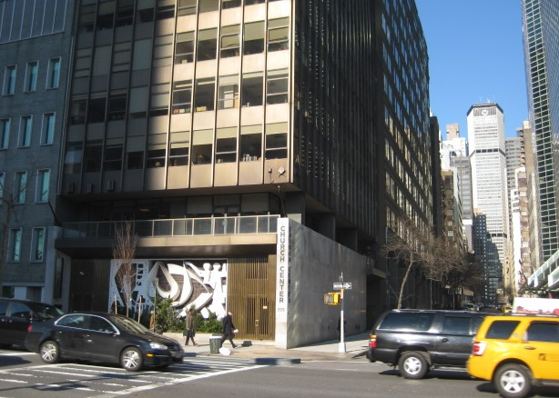
- Isolation and Exclusion from Decision Making

I joined the Ecumenical Women at the beginning of each day for worship and for briefing and explanation of what the day would bring. The US Presbyterian UN delegation welcomed me as well, and I found a home space in the UN Church Centre, across the road from the UN. I have agreed to work with the UN PCUSA team to present a parallel session, in conjunction with the World Alliance of Reformed Churches, at the 2013 CSW.

I also attended the CSW NGO orientation, where the issues for the CSW56 Sessions became clear.
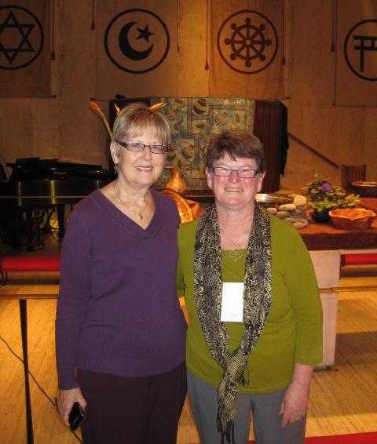

Each day, NGO’s from around the world (national and international groups, faith based groups, women’s organisations, aid and development agencies) presented workshops, and we had a daily choice from about 20 events (in four slots). Mostly they were held in the UN Church Centre. These were an excellent opportunity to hear how progress is being made in other countries and to network with participants. They were in addition to the Sessions of CSW and the member state presentations over at the UN, so there were many choices to be made! Frustratingly, obtaining passes to the UN Sessions was limited and had to be done daily; involving much planning. I chose to focus on workshops over a limited range of topics, specifically: Asia and Pacific regions, rural women in developing countries, climate change, women’s spirituality.

What I learned!!
- NZ is highly respected as a bridge builder at the UN and forms alliances on issues, not just within blocks of member states. NZ’s participation in international affairs is valued above our weight in terms of population and wealth etc.
- We recognised that the Pacific is not well represented in international circles: as part of the UN region “Asia and Pacific,” their stronger neighbours dominate and the Pacific countries are too poor to have big delegations of either government or NGO’s. Asia Pacific Women’s Watch (NZ) works hard to bring representatives from the Pacific and Presbyterian Women should support this, from our connections in mission.
- In many of workshops we attended we heard stories of the extent of violence against women:
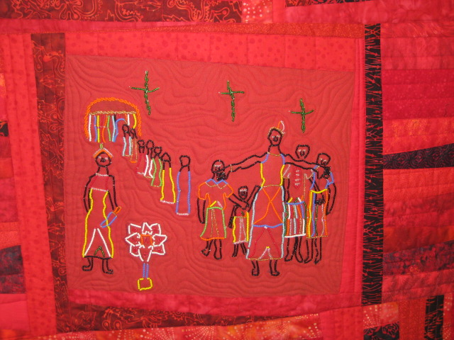
  - In countries where the rape of women is seen as a weapon of war,
  - the huge occurrence of sex trafficking and slavery of young girls
  - the acceptance by societies of domestic violence
  - the violence of inferior care of the girl child, and genital mutilation
  - the absence of maternal health care and the incidence of HIV/aids
  - the violence of poverty: borne mostly by the women and children of the world.
- We noticed the huge difference between developed and developing states in perception on the issues of woman. It also highlighted in which side of the world we in NZ are and how much power and safety that gives us. The issues that face rural women in developing countries are of a different order for our stress points for rural women in NZ.
- We are not trained at advocacy in NZ circles, and are fortunate to be able to rely on communication and easy access to government departments and elected representatives to bring about changes. I learned much about advocacy at the UN, and with well grounded information and points of view presenting to those who have the opportunity to make a difference.
- I appreciated the ecumenical/faith based perspectives and common values that under pinned the work we were doing, and the excellent worship presented.
- The global economic crisis has impacted most severely on countries with low GDP, and in NZ we have been fortunate to have been able to ride the storm comparatively easily.
- I recognised (again) that working for women’s rights is not only for the sake of women but for all of society. We all benefit when women participate fully in the spheres of education, politics, science, in economics and business as well in their traditional roles. Women do hold up half the sky! But for many (most?) states, especially developing ones, the paradigm shift that allows men to share power is too big a threat.

