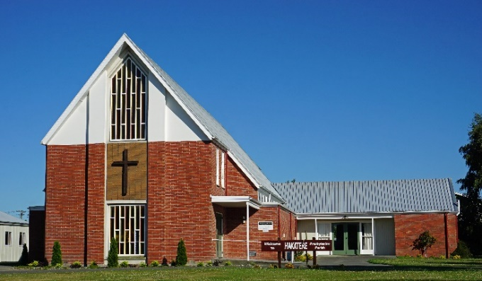**Ministry Opportunity – half-time role**

Hakatere Presbyterian Church (Ashburton) has a ministry vacancy.

The Hakatere Parish was formed in 2019 from the former St Pauls (Hampstead) and St James (Tinwald). Worship and activities are now all located in the former St Paul’s site in Hampstead (see photo).

The parish consists of a mix of energetic and experienced adults, from various cultures and backgrounds.

We are looking for a nationally ordained minister who is:

* A good preacher – relevant, challenging, inspiring, and able to extend theological thinking
* A capable leader who can teach/coach and is able to collaborate and lead change
* Able to lead a vision for the future strategically
* Caring and approachable with good listening/communication skills

We are looking for someone who can:

* + Lead at least two worship services a month and include a reflection which brings scripture alive in our context
  + Relate positively with a wide cross-section of understanding, age, ethnicities
  + Work with and support our pastoral worker
  + Complement our outreach programs pastorally and within the wider community
  + Become part of developing the concept of cooperation with other churches in Mid-Canterbury, while retaining our individual identities

Standard PCANZ terms of call, are offered at half-time rate.

Expressions of interest are invited and can be made, prior to Thursday 31 October, to the convenor of the Ministry Settlement Board Rev Anne Stewart [annestewart856@gmail.com](mailto:annestewart856@gmail.com) who will provide further details.