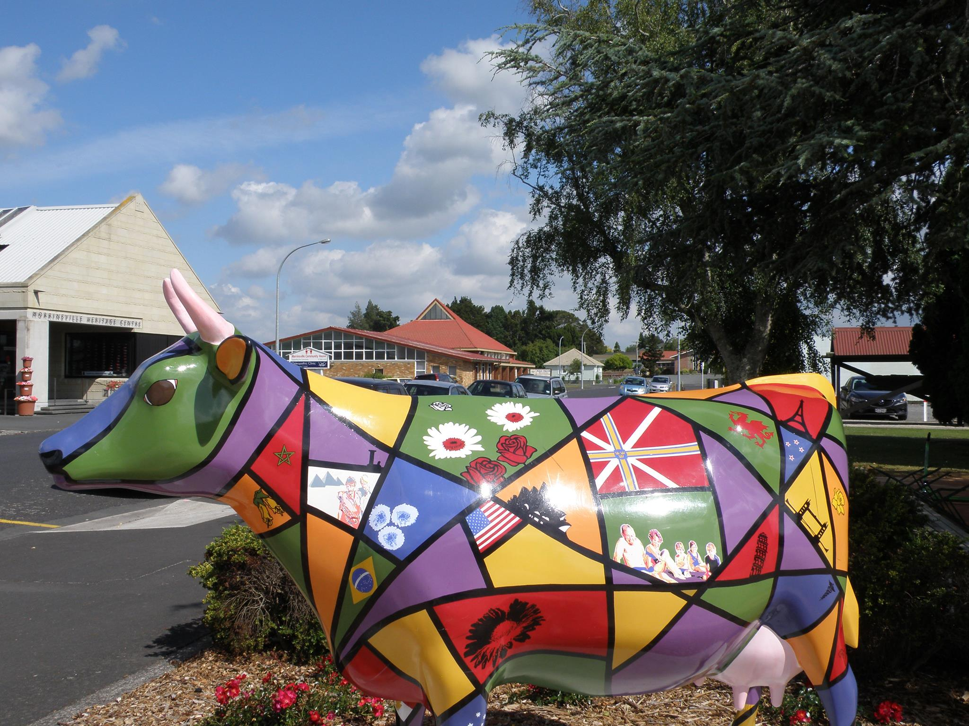**Come join us in the Heart of the Waikato**

**Knox Morrinsville** is seeking a minister, in a part-time capacity. We seek to honor God through worship which is Holy Spirit lead with preaching that is creative, relevant and bible based. We are excited to be a part of the new “City to City” project and look forward to how it might shape our future.

**Our new Minister should have qualities that include**

* A sense of God's call to be part of our future.
* Being Prayerful
* Holy Spirit lead
* A heart to be involved in Pastoral care
* Keen to visit people in their homes
* Believes that baptism is important regardless of age
* Able to relate to people of diverse backgrounds and understandings, and hold them together

**As a church family we will:**

* Welcome you and your family into our faith community and the community around us.
* Uphold you in prayer.
* Provide a comfortable, modern manse.
* Encourage you to be who God has made you to be as you work alongside and with us.

**Applications, expressions of interest or for further information please contact**

**MSB Convenor**: **Phil Bettany** [**revphilipbettany@gmail.com**](mailto:revphilipbettany@gmail.com) **022 126 1353**

**Applications close 16 September**